Supplementary Materials for
Spatiotemporal Characteristics and Driving Factors of Snow Drought in the Mongolian Plateau

Guna Ari¹, Hanfu Asi², Yingxia Gao¹, Qing Zhang^{1,3,4,*}

¹ Ministry of Education Key Laboratory of Ecology and Resource Use of the Mongolian Plateau, School of Ecology and Environment, Inner Mongolia University, Hohhot 010022, China
² College of Geographical Science, Inner Mongolia Normal University, Hohhot 010022, China
³ Collaborative Innovation Center for Grassland Ecological Security (Jointly Supported by the Ministry of Education of China and Inner Mongolia Autonomous Region), Hohhot 010022, China
⁴ Inner Mongolia Agro-Pastoral Ecotone Field Scientific Observation and Research Station, Hohhot 010021, China
* Corresponding author at: Ministry of Education Key Laboratory of Ecology and Resource Use of the Mongolian Plateau, School of Ecology and Environment, Inner Mongolia University, Hohhot 010021, China. E-mail address: qzhang82@163.com.

Contents of this file
TableS1-S5
Appendix S1-S3
Figs S1-S4

Appendix S1
Previous evaluations indicate that ERA5-Land snow products can exhibit non-negligible regional biases, particularly a potential overestimation of snow water equivalent (SWE). (Muñoz-Sabater et al. 2021; Monteiro and Morin 2023). Because SWE is commonly inferred from snow depth and snow density (Xiong et al. 2025). And snow density is often prescribed as a constant across snow types and months. We focused our validation on ERA5-Land monthly snow depth. Observed snow depth was obtained from the NOAA National Centers for Environmental Information, which provides historical records spanning 1929–2022. We aggregated daily observations to monthly means and converted the original inch-based measurements to millimeters. To enhance the robustness of the validation, stations were screened based on record continuity, monthly completeness, and data reliability, yielding a set of stations with relatively high monthly data availability for 1973–2022. Because data completeness varies by year, the number of valid stations differs across years. After collocating station locations with corresponding ERA5-Land grid cells, we obtained 6,570 matched station–grid samples for the subsequent evaluation, as reported below.
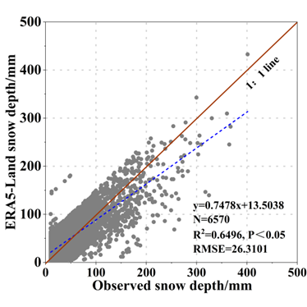
Fig. S1 Validation of ERA5-Land snow depth against observed snow depth.

Table S1 Detailed description of extreme climate indices.
Index Code | Index Name | Definition | Units
TX10p | Cool days | Percentage of days when the daily maximum temperature is below the calendar-day 10th-percentile threshold | %
TN10p | Cool nights | Percentage of days when the daily minimum temperature is below the calendar-day 10th-percentile threshold | %
ID0 | Ice days | Annual number of days when the daily maximum temperature is below 0 °C | day
CSDI | Cold spell duration index | Annual number of days occurring in periods of at least six consecutive days when the daily minimum temperature is below the calendar-day 10th-percentile threshold | day
CDD | Consecutive dry days | Maximum number of consecutive days with daily precipitation below 1 mm | day

Table S2 Description of topographic factors.
Topographic | Description
DEM | Elevation above sea level in meters
Slope | Steepness in degrees
Aspect | Compass direction in degrees
TPI | TPI gives information about the relative position of each pixel to the surrounding pixels. Positive and negative values mean that the pixels are higher or lower than the surrounding pixels, respectively
TWI | TWI is a useful tool to describe moisture conditions at the watershed scale. This index quantifies the effect of topography on runoff production
WEI | This index is the average value of the influence of each wind direction on the regional wind effect. The larger the WEI, the more vulnerable the area is to wind

Table S3 Data Sources.
Dataset | Sources | Variables (units) | Time period | Resolution
ERA5-Land reanalysis | European Centre for Medium-Range Weather Forecasts https://cds.climate.copernicus.eu/datasets/reanalysis-era5-land-monthly-means?tab=download | Daily: Tmax (℃), Tmin(℃), Tmean(K), PRE(mm);  Monthly: TEM(℃), PRE(mm), Tdew(℃), u10(m s⁻¹), v10(m s⁻¹), SSR(J m⁻²), SM (0–7 cm) (m³ m⁻³), SWE(m) | 1951–2024 | 0.1° × 0.1°; daily and monthly
Atmospheric circulation indices | NOAA Physical Sciences Laboratory https://psl.noaa.gov/ | AO, NAO, PDO, MEI, AMO | 1979–2022 | Monthly time series
Digital Elevation Model (DEM) | Geospatial Data Cloud (CAS CNIC) https://www.gscloud.cn/ | DEM, Slope, Aspect, TPI, TWI, WEI |  | 90 m (DEM)
Snow depth observations | NOAA National Centers for Environmental Information (NCEI) https://www.ncei.noaa.gov/access | Snow depth (mm) | 1951–2024 | Point observations
Historical drought/disaster records (Inner Mongolia) | China Meteorological Disaster Encyclopedia: Inner Mongolia Volume; Chinese Meteorological Disaster Yearbook | Drought ("black disaster") and event records | 1950–2000; 2004–2022 | Administrative/event records

Appendix S2
The validation proceeded as follows: each historical drought (black disaster) record was compared with the SWEI-based monitoring result for the same region and period. According to the degree of agreement on the ordinal drought grade scale, cases were classified into three categories: “corresponds” (c), defined as exact agreement between the drought grade reported in the historical record and the SWEI classification; “mainly corresponds” (mc), defined as a one category difference (adjacent classes); and “discordant” (dis), defined as a difference of two or more categories. Detailed results are presented in Table S4.

Table S4 Validation results of SWEI for snow drought in Inner Mongolia.
No. | Time | Site(s) | Historical record | Historical drought grade | SWEI-derived drought grade | Correspondence
1 | Winter 1957 to spring 1958 | Hulunbuir City | Ulanqab City and Baotou City were the most severely affected; there was virtually no snow cover throughout the winter. The affected area was 1.1624 million hectares, and livestock mortality among affected herds was 3.5%. | Severe | Hulunbuir City (Normal) | dis
2 | Winter 1957 to spring 1958 | Xilingol League |  | Severe | Xilingol League (Normal) | dis
3 | Winter 1957 to spring 1958 | Ulanqab City |  | Severe | Ulanqab City (Normal) | dis
4 | Winter 1957 to spring 1958 | Baotou City |  | Severe | Baotou City (Normal) | dis
5 | Dec 1962–Feb 1963 | Hulunbuir City | Ulanqab City was most severely affected; in Bailingmiao, there were 117 consecutive days without snow cover from 26 Nov 1962 to 25 Mar 1963. | Severe | Hulunbuir City (Moderate) | mc
6 | Dec 1962–Feb 1963 | Xilingol League |  | Severe | Xilingol League (Moderate) | mc
7 | Dec 1962–Feb 1963 | Ulanqab City |  | Severe | Hulunbuir (Moderate) | mc
8 | Winter 1964–spring 1965 | Western Hulunbuir City | The drought lasted a long time and affected a broad area; the total affected area across the region was 2.4667 million hectares, with 4.09 million head of livestock affected. | Severe | Western Hulunbuir City (Moderate) | mc
9 | Winter 1964–spring 1965 | Hinggan League |  | Severe | Hinggan League (Moderate) | mc
10 | Winter 1964–spring 1965 | Northern Bayannur City |  | Severe | Northern Bayannur City (Severe) | c
11 | Winter 1964–spring 1965 | Xilingol League |  | Severe | Xilingol League (Severe) | c
12 | Dec 1965–Feb 1966 | Chifeng City | In Bairin Left Banner, early-season drought affected 14,700 hectares. In Ar Horqin Banner, due to drought, pasture growth was poor, livestock lost body condition, diseases prevailed, and 112,000 head of livestock died. | Severe | Chifeng City (Moderate) | mc
13 | Dec 1965–Feb 1966 | Xilingol League |  | Severe | Xilingol League (Severe) | c
14 | Dec 1965–Feb 1966 | Baotou City |  | Severe | Baotou City (Severe) | c
15 | Dec 1965–Feb 1966 | Northern Ulanqab City |  | Severe | Northern Ulanqab City (Severe) | c
16 | Dec 1965–Feb 1966 | Northern Bayannur City |  | Severe | Northern Bayannur City (Severe) | c
17 | Nov 1966–Feb 1967 | Northern Ulanqab City | From winter to the following spring, a region-wide severe black dzud occurred across pastoral areas. Livestock mortality rates were 36.4% for sheep and 35.8% for camels in Urad Rear Banner; total livestock numbers decreased by 160,000 head compared with the previous year across the league and by 1.633 million head overall; in Darhan Muminggan United Banner, livestock mortality was 36%; East Ujimqin Banner lost 96,000 head; Xianghuang Banner decreased by 24,000 head from the previous year. | Extreme | Northern Ulanqab City (Moderate) | dis
18 | Nov 1966–Feb 1967 | Hinggan League |  | Extreme | Hinggan League (Moderate) | dis
19 | Nov 1966–Feb 1967 | Northern Bayannur City |  | Extreme | Northern Bayannur City (Extreme) | c
20 | Nov 1966–Feb 1967 | Xilingol League |  | Extreme | Xilingol League (Moderate) | dis
21 | Nov 1968–Feb 1969  1969 | Hulunbuir City | From the onset of winter, pastoral areas west of Xilingol League experienced continuous little or no snow. Because of severe summer-long drought, livestock were weak. After overwintering, Ulanqab City had 307,000 head dead; in Xilingol League, East Ujimqin Banner lost 100,000 head, Sonid Right Banner 20,000 head, Sonid Left Banner 50,000 head; the total affected pasture area across the region was 25 million hectares, with 1.43 million head of livestock lost. | Severe | Hulunbuir City (Moderate) | mc
22 | Nov 1968–Feb 1969  1969 | Xilingol League |  | Severe | Xilingol League (Moderate) | mc
23 | Nov 1968–Feb 1969  1969 | Ulanqab City |  | Severe | Ulanqab City (Moderate) | mc
24 | Nov 1968–Feb 1969  1969 | Bayannur City |  | Severe | Bayannur City (Severe) | c
25 | Nov 1973–Feb 1974 | Chifeng City | From late winter to the following spring, the northern pastoral areas of Ulanqab City, Xilingol League, northern Bayannur, Chifeng City, and northern Tongliao City had markedly below-normal snowfall, long durations without snow cover, resulting in a region-wide black dzud. In Darhan Muminggan United Banner, snowfall totals were 3.4 mm from Nov to Feb, 70% below normal; in Xianghuang Banner (Xilingol), Nov–Mar snowfall was 1.7 mm, 90% below normal; in Zhalute Banner (Tongliao), Dec–Feb snowfall was 0.6 mm, 18.1% of normal. These areas had fewer than 5 days with snow cover from Nov to Feb, while snow-free days reached 74. Livestock had no snow to eat, body condition declined, and mass mortality occurred: Ulanqab recorded 544,000 head of livestock deaths; Xianghuang Banner >26,000 head; in Ar Horqin Banner and Bairin Right Banner (Chifeng), nearly 500,000 head were threatened by black dzud. | Extreme | Chifeng City (Extreme) | c
26 | Nov 1973–Feb 1974 | Tongliao City |  | Extreme | Tongliao City (Extreme) | c
27 | Nov 1973–Feb 1974 | Baotou City |  | Extreme | Baotou City (Extreme) | c
28 | Nov 1973–Feb 1974 | Hulunbuir City |  | Extreme | Hulunbuir City (Severe) | mc
29 | Nov 1973–Feb 1974 | Northern Ulanqab City |  | Extreme | Northern Ulanqab City (Extreme) | c
30 | Nov 1973–Feb 1974 | Xilingol League |  | Extreme | Xilingol League (Severe) | mc
31 | Nov 1973–Feb 1974 | Northern Bayannur City |  | Extreme | Northern Bayannur City (Extreme) | c
32 | Nov 1974–Feb 1975 | Tongliao City | In Sonid Right and Sonid Left Banners (Xilingol), the affected area was 2.3945 million hectares with a livestock mortality rate of 1.3%. In western Hulunbuir and Tongliao City, the affected area was 1.3533 million hectares with a livestock mortality rate of 8%. | Extreme | Tongliao City (Severe) | mc
33 | Nov 1974–Feb 1975 | Hulunbuir City |  | Extreme | Hulunbuir City (Moderate) | dis
34 | Nov 1974–Feb 1975 | Xilingol League |  | Extreme | Xilingol League (Moderate) | dis
35 | Nov 1974–Feb 1975 | Ulanqab City |  | Extreme | Ulanqab City (Severe) | mc
36 | Dec 1975–Mar 1976 | Hulunbuir City | The overall affected area was 25 million hectares, with 1.9 million head of livestock lost. | Severe | Hulunbuir City (Severe) | c
37 | Dec 1975–Mar 1976 | Xilingol League |  | Severe | Xilingol League (Severe) | c
38 | Dec 1975–Mar 1976 | Ulanqab City |  | Severe | Ulanqab City (Severe) | c
39 | Dec 1975–Mar 1976 | Bayannur City |  | Severe | Bayannur City (Severe) | c
40 | Dec 1979–Feb 1980 | Xilingol League | From February to April, Darhan Muminggan United Banner and Siziwang Banner had an affected area of 1.7857 million hectares; livestock mortality was 3.4%. | Extreme | Xilingol League (Severe) | mc
41 | Dec 1979–Feb 1980 | Northern Ulanqab City |  | Extreme | Northern Ulanqab City (Severe) | mc
42 | Dec 1979–Feb 1980 | Baotou City |  | Extreme | Baotou City (Severe) | mc
43 | Dec 1979–Feb 1980 | Northern Bayannur City |  | Extreme | Northern Bayannur City (Severe) | mc
44 | Nov 1983–Feb 1984 | Xilingol League | In Ulanqab City and Baotou, the affected area was 1.3707 million hectares; livestock mortality was 5.5%. | Severe | Xilingol League (Severe) | c
45 | Nov 1983–Feb 1984 | Northern Ulanqab City |  | Severe | Northern Ulanqab City (Severe) | c
46 | Nov 1983–Feb 1984 | Baotou City |  | Severe | Baotou City (Severe) | c
47 | Nov 1983–Feb 1984 | Northern Bayannur City |  | Severe | Northern Bayannur City (Severe) | c
48 | Nov 1988–Feb 1989 | Xilingol League | From early winter to the following spring there was continuously little snow; pastures yellowed, groundwater levels declined; the affected area was 11.5 million hectares, with 4.08 million head of livestock affected. | Extreme | Xilingol League (Severe) | mc
49 | Spring 2003 | Eastern Inner Mongolia | In some areas, there were no precipitation events ≥10 mm; a dry soil layer reached 35 cm; farmland soil moisture was extremely poor; livestock body condition declined. | Moderate | Eastern Inner Mongolia (Moderate) | c
50 | Jan 2004–mid-Jun 2004 | Hinggan League | By 16 Jun, the drought-affected area reached 341,000 hectares, with 133,000 hectares of late-season fields awaiting rain for sowing. In Tongliao City, many reservoirs and rivers dried up; soil moisture was extremely poor; as of 25 May, 200,000 hectares were unseeded, with 371,000 hectares of dryland lacking moisture and 13,000 hectares of paddy fields lacking water. In Chifeng City, the farmland area lacking soil moisture was 733,000 hectares; crops already sown had poor stands and weak growth. | Severe | Hinggan League (Moderate) | mc
51 | Jan 2004–mid-Jun 2004 | Tongliao City |  | Severe | Tongliao City (Severe) | c
52 | Jan 2004–mid-Jun 2004 | Chifeng City |  | Severe | Chifeng City (Severe) | c
53 | Jan 2004–mid-Jun 2004 | Western Hulunbuir |  | Severe | Western Hulunbuir (Moderate) | mc
54 | To Apr 2005 | Xilingol League | In Xilingol pastoral areas, the drought-affected pasture area was 13.22 million hectares; the northern border area was the most severely affected. | Severe | Xilingol League (Severe) | c
55 | Spring–Jun 2005 | Hanggin Banner | Parts of these banners suffered severe drought with no effective precipitation; rangeland was in severe drought; forage grasses desiccated and died. | Severe | Hanggin Banner (Severe) | c
56 | Spring–Jun 2005 | Otog Banner |  | Severe | Otog Banner (Severe) | c
57 | Spring–Jun 2005 | Otog Front Banner |  | Severe | Otog Front Banner (Severe) | c
58 | Autumn 2006 | Central Inner Mongolia | Precipitation was <50 mm and soil moisture was insufficient. In southern Alxa League, the severely drought-affected natural rangeland area was ~7 million hectares (40% of the league’s rangeland), and the mildly drought-affected area was ~10.4 million hectares (60%). Wuhai City had almost no precipitation and a dry soil layer of 19 cm. In Chifeng City, 8.04 million hectares of crops were affected in September, with a grain reduction of 410 million kilograms; drought-affected rangeland area was 3.1 million hectares. | Severe | Central Inner Mongolia (Severe) | c
59 | Autumn 2006 | Western Inner Mongolia |  | Severe | Western Inner Mongolia (Severe) | c
60 | Mid-Aug–Nov 2007 | Parts of Eastern Inner Mongolia | Persistent high temperatures and little rainfall caused summer–autumn consecutive drought; northern parts of the east were severely affected, reaching exceptional drought levels. | Severe | Eastern parts of Inner Mongolia (Severe) | c
61 | Jan 2008 | Chifeng City | Chifeng and Tongliao had essentially no precipitation; combined with earlier markedly below-normal precipitation, drought persisted. Except for Gangzi and Jinshan (which had 152 consecutive dry days), most areas had 169–176 consecutive dry days. | Severe | Chifeng City (Severe) | c
62 | Jan 2008 | Tongliao City |  | Severe | Tongliao City (Severe) | c
63 | Sep–late Oct 2008 | Hinggan League | In September, parts of Hinggan League experienced severe to exceptional drought. By late September, most areas of Chifeng had 47–52 consecutive dry days; nearly 50,000 hectares of cropland and nearly 500,000 hectares of rangeland were drought-affected. By late October, drought was most severe; most areas had 71–82 consecutive dry days, with a maximum of 114 days. | Severe | Hinggan League (Moderate) | dis
64 | Sep–late Oct 2008 | Chifeng City |  | Severe | Chifeng (Moderate) | dis
65 | Autumn 2009 | Southern Xilingol League | Drought in Chifeng City was very severe; most areas experienced 75–90 consecutive dry days, reaching 118 days in Aohan Banner. | Severe | Southern Xilingol League (Severe) | c
66 | Autumn 2009 | Chifeng City |  | Severe | Chifeng City (Moderate) | mc
67 | Autumn 2009 | Southern Tongliao City |  | Severe | Southern Tongliao City (Moderate) | mc
68 | Dec 2013–3 Feb 2014 | Central–Western Inner Mongolia | Essentially no precipitation; compared with the same period in normal years, precipitation deficits generally exceeded 80%. | Severe | Central–Western Inner Mongolia (Severe) | c
69 | Mid-Feb–late Apr 2014 | Eastern Inner Mongolia | Rainfall was generally <30 mm, and <10 mm in the northeast. Compared with normal, deficits were typically 20%–80% below normal, locally >80% below. | Extreme | Eastern Inner Mongolia (Extreme) | c
70 | Nov 2014–Mar 2015 | Central Inner Mongolia | Precipitation was generally 20%–50% below normal for the same period, and >50% below normal in central parts. | Severe | Central Inner Mongolia (Severe) | c
71 | Nov 2014–Mar 2015 | Western Inner Mongolia |  | Severe | Western Inner Mongolia (Severe) | c
72 | Spring–Summer 2018 | Bayannur City | From March to mid-June, the drought-affected area reached 61%; severe to exceptional drought was mainly in the east. In Hinggan League, Chifeng, and Tongliao, almost all counties/banners were affected; some cropland could not be sown and pasture green-up was hindered. After August, increased rainfall in the east alleviated drought, while the drought area expanded in central parts. | Severe | Bayannur City (Moderate) | mc
73 | Spring–Summer 2018 | Xilingol League |  | Severe | Xilingol League (Severe) | c
74 | Spring–Summer 2018 | Chifeng City |  | Severe | Chifeng City (Severe) | c
75 | Spring–Summer 2018 | Tongliao City |  | Severe | Tongliao City (Moderate) | mc
76 | Spring–Summer 2018 | Hinggan League |  | Severe | Hinggan League (Moderate) | mc
77 | Spring–Summer 2018 | Hulunbuir City |  | Severe | Hulunbuir City (Moderate) | mc
Legend: dis = discordant; mc = mainly corresponds; c = corresponds. Summary: Total = 77; dis = 11; mc = 26; c = 40; overall agreement = 85.71%.

Table S5 Types of interactions between the independent and dependent variables.
Classification criteria | Interaction type
q(X1 ∩ X2) < Min(q(X1), q(X2)) | Weaken; nonlinear
Min(q(X1),q(X2)) < q(X1 ∩ X2) < Max(q(X1),q(X2)) | Weaken; univariate
q(X1 ∩ X2) > Max(q(X1), q(X2)) | Enhanced; mutual (bivariate)
q(X1 ∩ X2) = q(X1) + q(X2) | Independent
q(X1 ∩ X2) > q(X1) + q(X2) | Enhanced; nonlinear

Appendix S3
Here, we describe the calculations and workflow for the key analyses.
1. SWE data preparation and SWEI processing procedure
Step 1: Data acquisition and variable definition (ERA5-Land)
This study used the ECMWF ERA5-Land reanalysis dataset (1951–2024). An index was constructed based on snow water equivalent (SWE). In ERA5-Land, SWE is reported in “m of water equivalent” in the product documentation and can be directly used to represent SWE.

Step 2: Spatial preprocessing (ArcGIS Pro / ArcPy)
To ensure consistency in pixel-wise time-series calculations, the SWE data were spatially standardized. Specifically, the data were clipped to the Mongolian Plateau boundary, while preserving the native 0.1° ERA5-Land grid (consistent extent, projection, and spatial resolution).

Step 3: Construction of 3-month SWE series (MATLAB)
Based on the monthly SWE series, a 3-month moving accumulation series was generated to capture the magnitude and persistence of seasonal snow storage. This step was implemented in MATLAB using pixel-wise rolling calculations.

Step 4: Nonparametric normalization to derive SWEI (MATLAB)
Following the nonparametric normalization approach of Farahmand and AghaKouchak (2015), the 3-month accumulated SWE series was transformed into a standardized index (SWEI). To avoid distortions in the empirical distribution caused by zero values, a small positive perturbation was applied to zero SWE values. Cumulative probabilities were then derived from the empirical distribution and converted to SWEI through a standard normal transformation.

Step 5: Extraction of annual representative SWEI (annual peak-month approach)
To obtain an annual representative metric, we identified, for each pixel and year, the month when SWE reaches its annual maximum (the annual peak month) and extracted the corresponding SWEI as the annual representative SWEI for that pixel-year.

2. Data preparation and processing for the Geographical Detector analysis
Step 1: Define the analysis unit and study periods
We used 0.1° grid cells as the spatial analysis units and divided the study period into two phases (1951–1999 and 2000–2024) to provide a consistent framework for comparing driver mechanisms between periods.

Step 2: Prepare the dependent variable (SWEI)
We imported the precomputed SWEI dataset and aggregated it by period to generate the corresponding dependent-variable rasters and tabular fields, ensuring that each grid cell has a single SWEI value for each phase.

Step 3: Prepare the driving-factor datasets (continuous and categorical variables)
We compiled meteorological, extreme-climate, and topographic drivers (mostly continuous variables, with categorical variables retained as such). All drivers were spatially aligned with SWEI, sharing the same resolution, extent, projection, and grid.

Step 4: Spatial harmonization (ArcGIS Pro / ArcPy)
Using ArcGIS Pro, we applied consistent preprocessing to SWEI and all drivers, including clipping to the study region, resampling, and applying a consistent mask. The outputs were exported as a set of co-registered rasters suitable for subsequent statistical analysis.

Step 5: Raster-to-table conversion and sample construction (R)
We extracted SWEI and all driver rasters to a pixel-wise table. Samples with missing or invalid values were removed to ensure that all variables in each row correspond to the same grid-cell location.

Step 6: Discretize continuous drivers (R package GD)
Because the q statistic is derived from within-stratum and between-stratum variance, continuous drivers must be discretized into categorical strata. We used the one-step gdm () procedure in the R package GD, specifying continuous drivers in continuous_variable and testing four discretization schemes (equal interval, natural breaks, quantiles, and geometric intervals) with the number of strata ranging from 4 to 15. For each driver, the optimal scheme and number of strata were automatically selected by maximizing q, thereby reducing subjectivity in threshold selection.
Step 7: Run factor detection and export results
After optimal discretization, we performed factor detection to compute q values and their statistical significance, which quantify each driver’s explanatory power for the spatial heterogeneity of SWEI. We then exported ranked results and corresponding visualizations.

Step 8: Run interaction detection
We conducted pairwise interaction detection by comparing q(X₁), q(X₂), and q(X₁∩X₂) to diagnose interaction types (e.g., enhancement or weakening; linear or nonlinear; independence) and to identify synergistic driver combinations.

Step 9: Cross-period comparison and synthesis (period1(1951-1999) vs period2(2000-2024))
We repeated Steps 2–8 (or at minimum Steps 6–8) for each phase, compared dominant drivers and interaction structures between periods, and summarized the differences in the main text with figures and tables.

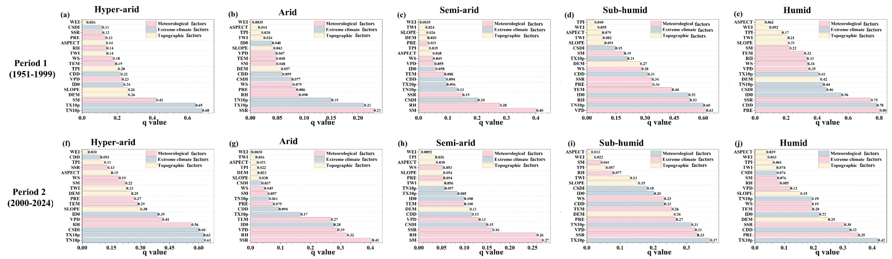
Fig.S2 Factor detection q-values for snow drought drivers across varying periods and climatic zones. (a) Period 1 (1951-1999): Hyper-arid; (b) Period 1 (1951-1999): Arid; (c) Period 1 (1951-1999): Semi-arid; (d) Period 1 (1951-1999): Sub-humid; (e) Period 1 (1951-1999): Humid; (f) Period 2 (2000-2024): Hyper-arid; (g) Period 2 (2000-2024): Arid; (h) Period 2 (2000-2024): Semi-arid; (i) Period 2 (2000-2024): Sub-humid; (j) Period 2 (2000-2024): Humid.

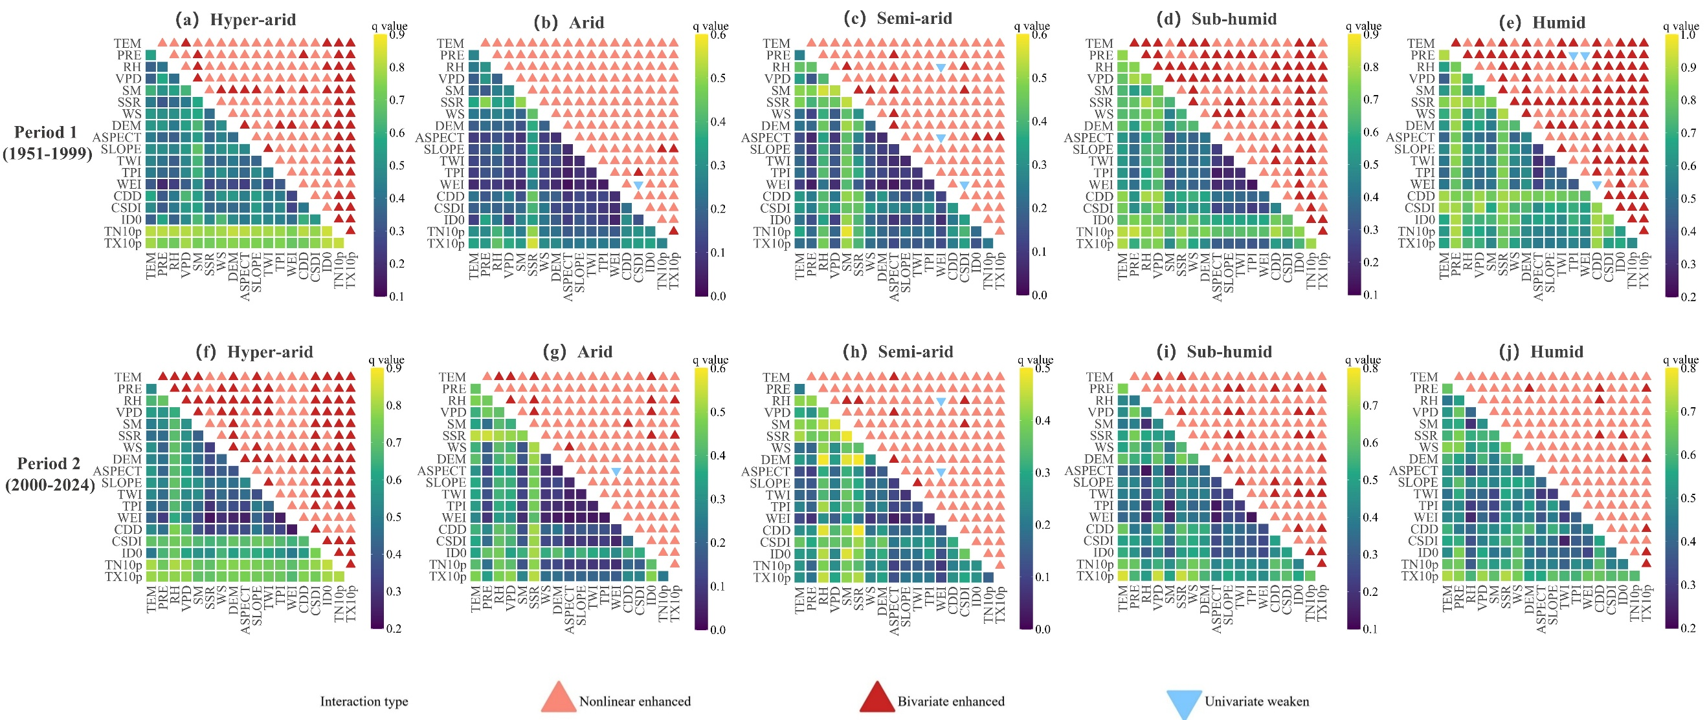
Fig.S3 Interaction detection results across different periods and climatic zones, with the lower triangle indicating the q-value and the upper triangle indicating the interaction type. (a) Period 1 (1951-1999): Hyper-arid; (b) Period 1 (1951-1999): Arid; (c) Period 1 (1951-1999): Semi-arid; (d) Period 1 (1951-1999): Sub-humid; (e) Period 1 (1951-1999): Humid; (f) Period 2 (2000-2024): Hyper-arid; (g) Period 2 (2000-2024): Arid; (h) Period 2 (2000-2024): Semi-arid; (i) Period 2 (2000-2024): Sub-humid; (j) Period 2 (2000-2024): Humid.

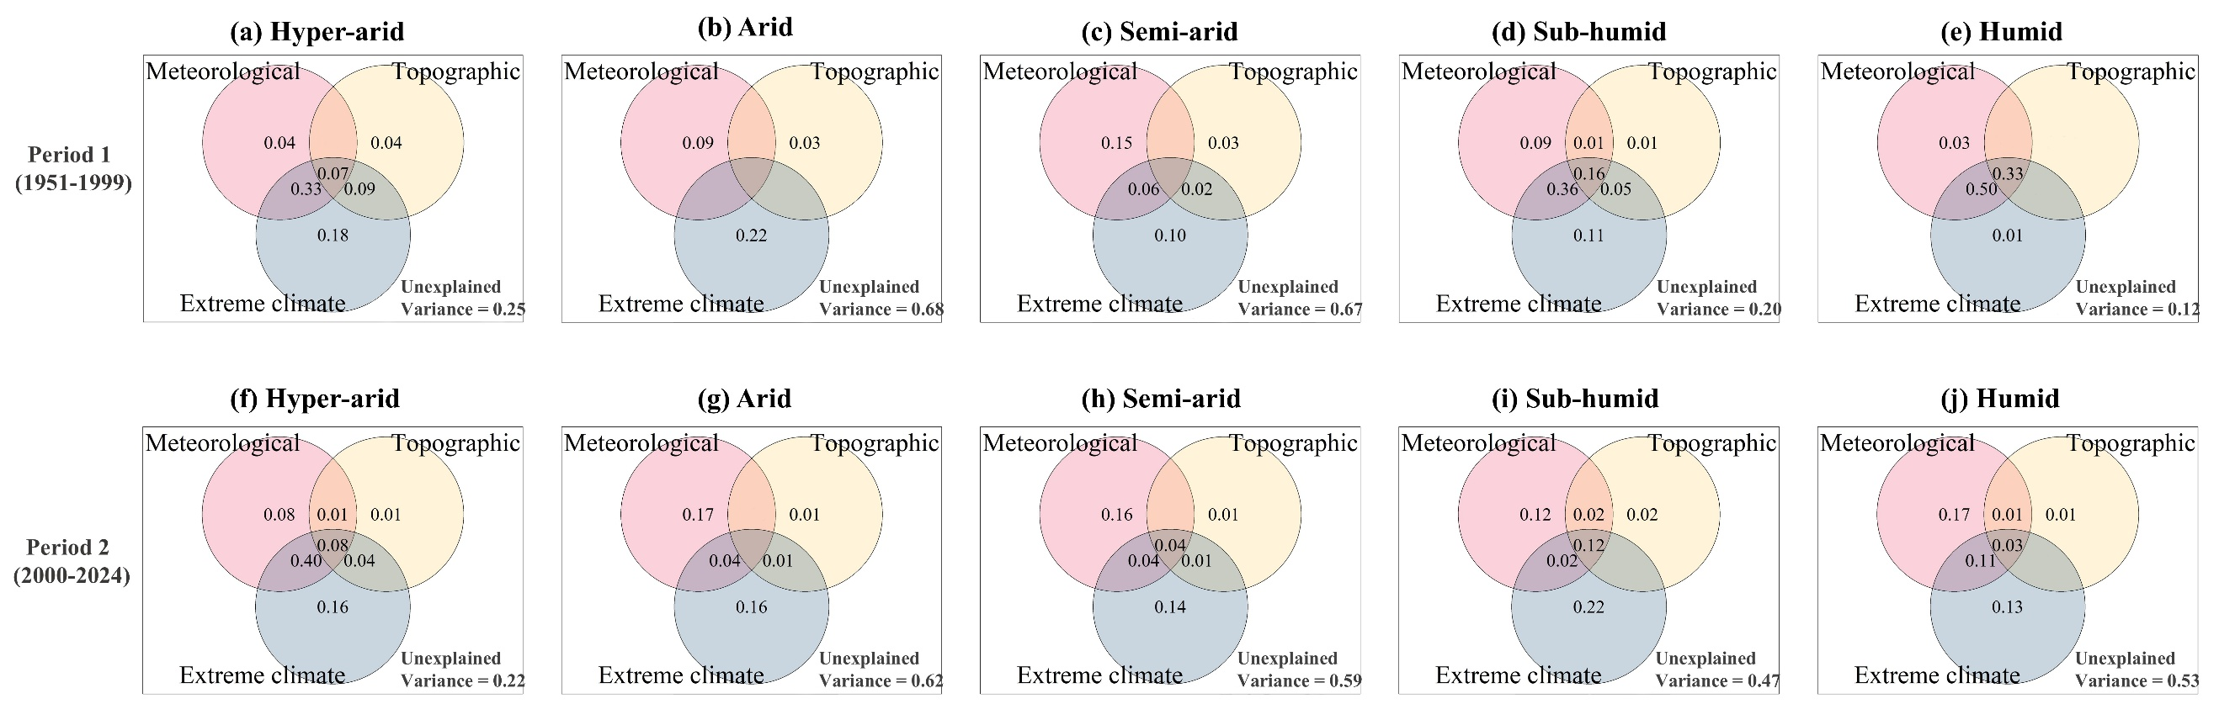
Fig.S4 Variance decomposition among factor groups across different periods and climatic zones. (a) Period 1 (1951-1999): Hyper-arid; (b) Period 1 (1951-1999): Arid; (c) Period 1 (1951-1999): Semi-arid; (d) Period 1 (1951-1999): Sub-humid; (e) Period 1 (1951-1999): Humid; (f) Period 2 (2000-2024): Hyper-arid; (g) Period 2 (2000-2024): Arid; (h) Period 2 (2000-2024): Semi-arid; (i) Period 2 (2000-2024): Sub-humid; (j) Period 2 (2000-2024): Humid.

Farahmand, A., and A. AghaKouchak. 2015. A generalized framework for deriving nonparametric standardized drought indicators. Adv. Water Resour. 76:140-145.
Monteiro, D., and S. Morin. 2023. Multi-decadal analysis of past winter temperature, precipitation and snow cover data in the European Alps from reanalyses, climate models and observational datasets. The Cryosphere 17 (8):3617-3660.
Muñoz-Sabater, J., E. Dutra, A. Agustí-Panareda, C. Albergel, G. Arduini, G. Balsamo, S. Boussetta, M. Choulga, S. Harrigan, H. Hersbach, B. Martens, D. G. Miralles, M. Piles, N. J. Rodríguez-Fernández, E. Zsoter, C. Buontempo, and J.-N. Thépaut. 2021. ERA5-Land: a state-of-the-art global reanalysis dataset for land applications. Earth. Syst. Sci Data. 13 (9):4349-4383.
Xiong, T., S. H. Du, X. Y. Zhang, and et al. 2025. An increasing delay in vegetation spring phenology over northern snow-covered landmass driven by temperature and snowmelt. Agric. For. Meteorol. 361:110310.

